**Project Initialization and Planning Phase**

|  |  |
| --- | --- |
| Date | 5 July 2024 |
| Team ID | 740298 |
| Project Name | FetalAI: Using Machine Learning To Predict And Monitor Fetal Health |
| Maximum Marks | 3 Marks |

**Define Problem Statements (Customer Problem Statement Template):**

This problem statement outlines the key issues with traditional fetal monitoring methods and proposes the objectives and challenges associated with integrating AI into this field. The integration of AI in fetal health monitoring is expected to enhance the accuracy, timeliness, and predictive capabilities of prenatal care. By improving early detection of complications, supporting data interpretation, and streamlining integration with existing systems, AI can contribute to better health outcomes for fetuses, ultimately advancing the quality and efficiency of prenatal care.

Top of Form

Bottom of Form

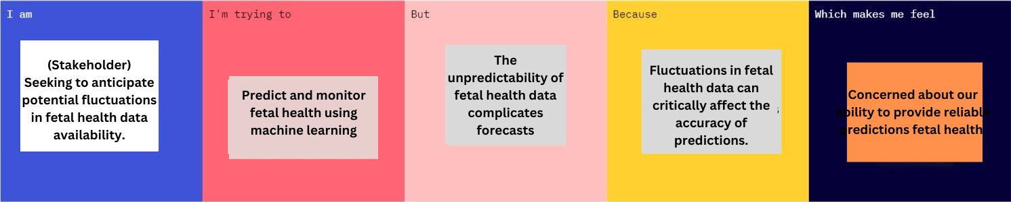

|  |  |  |  |  |  |
| --- | --- | --- | --- | --- | --- |
| **Problem**  **Statement**  **(PS)** | **I am**  **(Stakeholder)** | **I’m trying to** | **But** | **Because** | **Which makes me feel** |
| PS-1 | Seeking to anticipate potential fluctuations in fetal health data availability. | Predict and monitor fetal health using machine learning. | The unpredictability of fetal health data complicates forecasts. | Fluctuations in fetal health data can critically affect the accuracy of predictions. | Concerned about our ability to provide reliable predictions fetal health. |